Alexander Cannell

4/10/2013

Professor Robertson

Donald Blake Browser Timeline

**Introduction:**

Donald Blake was fired, and as an investigator I was asked to look at his computer to see his internet activity. Donald is suspected of stealing company info, and knowing he was going to get fired beforehand. The programs I used to find my information is FTK Imager, Excel, SkypeLogView, IEHistoryView, and Web Historian.

**Examination:**

I examined Donald’s history and found his last log in was 1/19/2009 at 10:51:28 AM, but Mr Blake was fired on the 16th so that is suspicious. I suspect that he didn’t log off his computer on Friday, He accessed his yahoo mail. Then we have this random “about:home” which was accessed in 2007, funny.



All his activity from the 13th to the 14th looks normal computer internet activity. But he did go to some random sites which makes me suspect that he knew he was going to get fired like craigslist, and Skype. I also suspect that he wanted to compress some data because he visited winzip.com and looks like he downloaded it too. This is some circumstantial evidence to prove he took data from the company.

I took a look at the chat messages in skype. The chat message between Donald Blake and frostgiant721 was very cryptic. I think this is where he was told he was getting fire, and it was frostgiant721that told him to do as much damage as possible before he left.

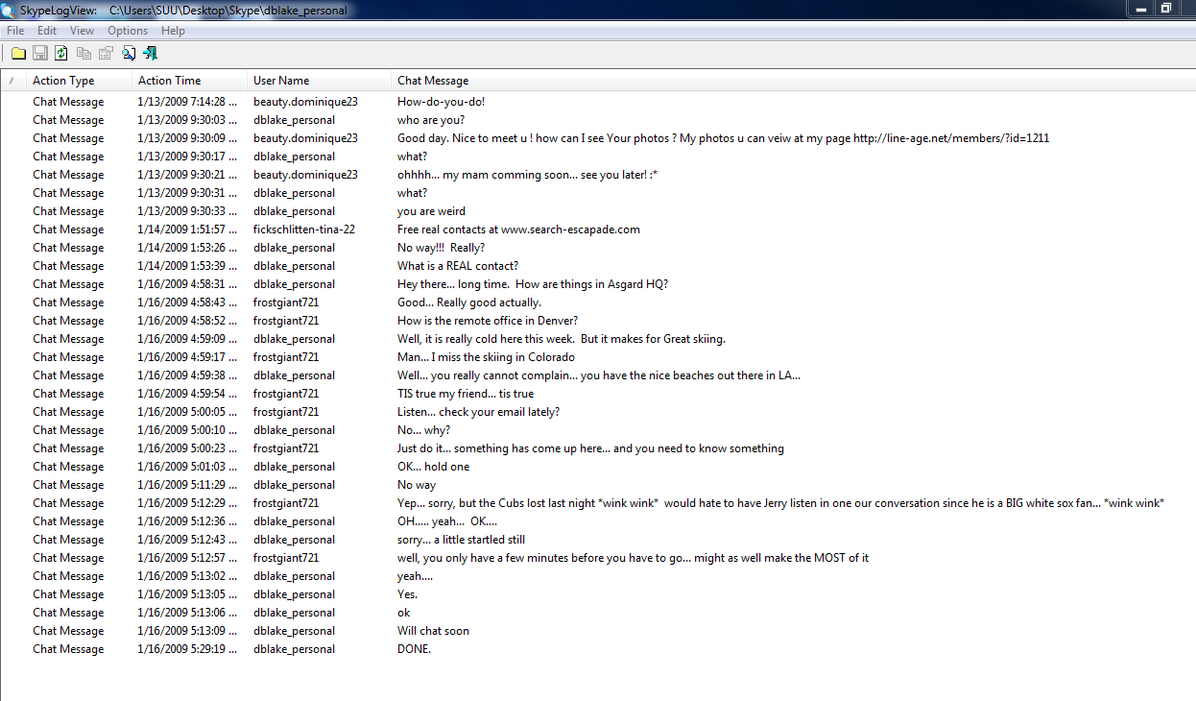

He a drive was accessed Falconii on the 16th by Donald. He accessed and transferred from this drive a File called Blue harvest Business Plan 20v1, Business Plans/Confidential_Spreedsheets, Research Confidential, research confidential – backup2, and Business Plans/Secret/Secret. It looks like he transferred those files on an external drive.

**Conclusion:**

I conclude that Donald Blake knew before he got fired on Friday that he was going to get fired, Frostgiant told him threw skype. I also can say that he stole a lot of confidential information from his previous employer. These are grounds for criminal action against him.